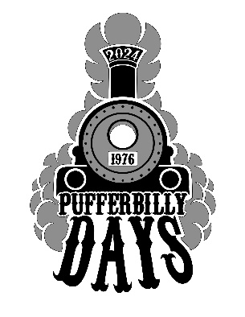

Pufferbilly Days - Boone ROCK THE RAILS 2024
Parade Application
Saturday, September 21st at 9:30 AM
Please print clearly
Group or Organization_________________________________________________________________
Primary Contact ______________________________________________________________
Address ____________________________________City___________ State _____________
Zip _____________________Email ________________________________________________
Phone ________________________________
- Parade Fee: Standard Entry $25

Will your entry have music?

- Yes
- No

Type of Entry (Include total number of vehicles or people as applicable)

- Float _____
- Other Marching Unit ______
- Horses ______
- Antique Vehicle ______
- Convertible ______
- Commercial Truck ______
- Tractor/Farm Equipment ______
- Semi Truck ______
- 4-Wheelers or Go Carts ______
- Other: _________________________

Division for Competition

- Judged Entry (select a category)
_____ Novelty
_____ Commercial
_____ Nonprofit
- I do not want my entry to be judged.

By submitting this application, you agree to follow the Parade Policies Return this registration application with cash or check payment payable to PUFFERBILLY DAYS.
Questions? Email
Pufferbilly Days
903 Story Street
Boone, IA 50036

Pufferbilly Days Parade Policies
All entries are subject to the approval of the parade committee with support from the Pufferbilly Days Steering Committee. Decisions are final.

THEME
The 2024 Pufferbilly Days theme is “Rock the Rails”
ENTRY TYPES
Floats – Judging scores will be decided by combining the scores from three areas:
Creative use of theme – crowd appeal, use of new and innovative ideas
Construction – quality of workmanship, use of materials
Details – animation, overall creativity, amount of work involved
Marching Units – These entries are open to any unit marching on foot and can be something any creative group can form. The parade must be kept moving to not create large gaps along the route, so a routine that keeps the group moving is necessary.
Politicians – All political entries should reach out to the Parade Chair, Janet Schultz for further instruction. Please call 515-230-0977 or expect a phone call upon receipt of your application.
RESTRICTIONS
For safety purposes, nothing is to be thrown from moving vehicles. Walkers are permitted to hand out candy or novelty giveaways.
Do NOT hand out brochures, coupons, or other paper items, as they are often left behind as litter. Groups whose handouts are found as litter after the parade will be banned from future parade participation.
The parade will be limited to 100 entries.
Entrants with animal units are expected to clean up after their animals in the parade lineup area and throughout the parade route. Please bring your own pooper-scooper!
*Company vehicles are allowed in the parade if they are pulling a float or are decorated with emphasis on the parade theme.
PARADE LINEUP INSTRUCTIONS
In mid-August, all approved entries will receive detailed instructions for the parade lineup, including the number in the parade and what time to line up based on their assigned number.
*DEADLINE
All entries postmarked after August 15 must include a $20 late fee, bringing the entry total to $45.

